🧭 Types of Roaming:
# Source: AI Source: Provided by: [Data Path: Persons Table -> ID Column: 1, Name_En Column: Motasem Essam] -> From: [ChatGPT] on [1/23/2026]
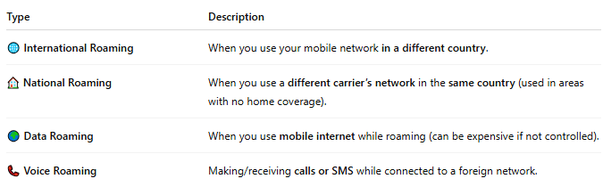

Type | Description
🌐 International Roaming | When you use your mobile network in a different country.
🏠 National Roaming | When you use a different carrier’s network in the same country (used in areas with no home coverage).
🌍 Data Roaming | When you use mobile internet while roaming (can be expensive if not controlled).
📞 Voice Roaming | Making/receiving calls or SMS while connected to a foreign network.

